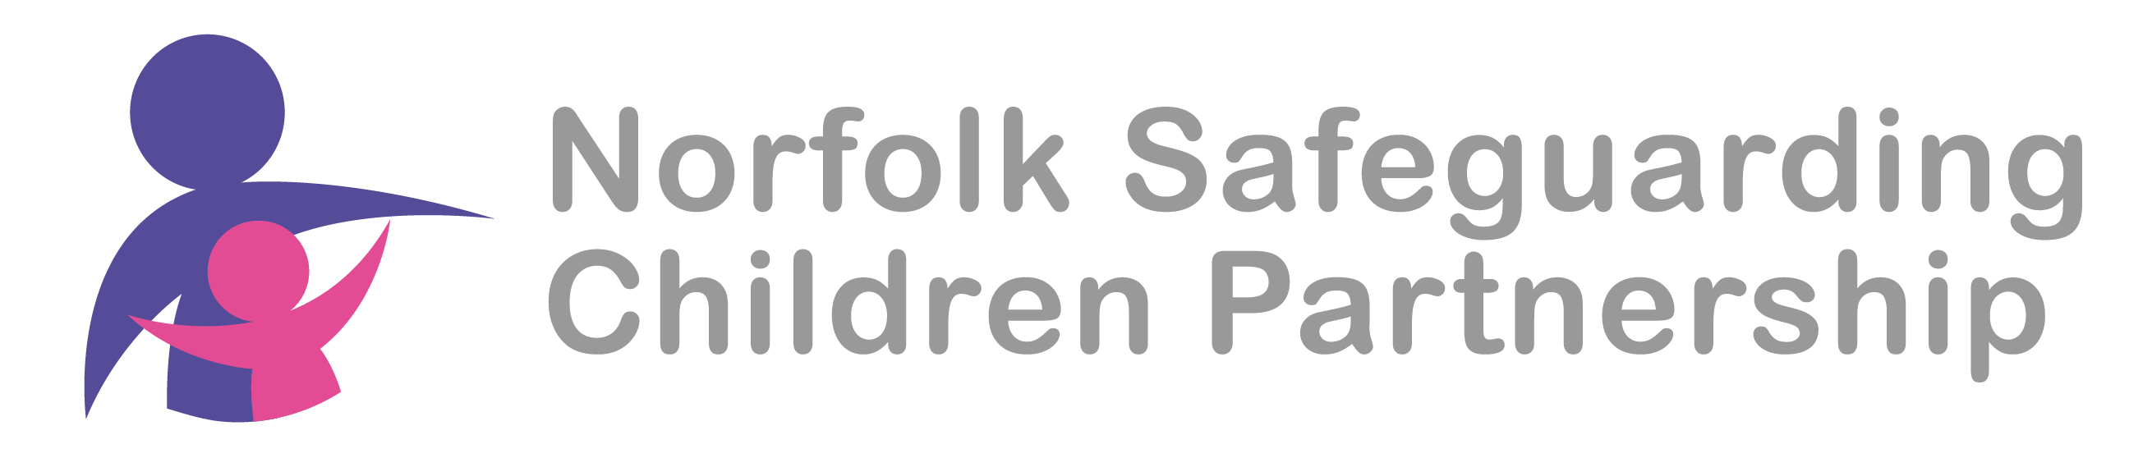
Norfolk Safeguarding Children Partnership (NSCP)
West Local Safeguarding Children Group
16th July 2024
10.30am
MS teams

Agenda

  - Welcome and introductions
  - Presentations from LSCG members
  - Norfolk Healthy Child Service
  - Family and community networking
  - Outline Family Help arrangements
  - Dates of next meetings

Attendees
Name | Job title/Organisation
Andy Nederpal | Community Safety Manager/ Kings Lynn and W Norfolk BC
Charlotte Marriott | Policy Officer/ Kings Lynn and W Norfolk BC
Lisa Barron | CCS
Phil Beck | Childrens Services
Vicky Horton | Childrens Services
Rachel Bazeley-Smith | DSL - Smithdon High
Fiona Armstrong | Police
Simon Barnet | LAC Childrens Services
Emma Gore Rowe | DSL
Julie Robinson | CWA
James moss | CAMHS
Elanor Goldup | Local First Inclusion Adviser/NCC
Jeanette Nowrung | ECFS
Katharine Robinson | FGC & Family Networking Advisor/NCC
Mark Osborn | SIPCo/NSCP

- PB welcomed all to members to the meeting and colleagues introduced themselves.

- Presentations from LSCG members
Andy Nederpel tried to share his presentation but it was too large to send.
Community Alcohol Partnership is across the whole of West Norfolk but it is difficult to make this high profile due to capacity.
AN links with schools and the college to alert colleagues re drug promotion stickers when concerns appear.

- Healthy Child Programme
LB presented on the changes happening around Healthy child Programme becoming the Healthy Child Service.

PB talked to colleagues about the Pathway to Parenting offer.

We will learn more about the 5-19 offer in the autumn.
It is good if colleagues sign up for a JON account as this will support their use of the website
At the Norwich LSCG it was highlighted that we need to consider how users with learning difficulties access the site and LB will be taking this back to Fay Spencer (FS) to consider
MO will share the link to the briefing from FS about how to navigate the FYI website for young people
https://norfolklscp.org.uk/people-working-with-children/local-safeguarding-children-groups-lscgs

- Family and Community Networking

PB talked about our priorities neglect, child exploitation and there was discussion around Family and Community Networking and how this has a focus on the natural networks of support that exists or could exist around children or families and how these can be supported and encouraged by partners and colleagues.
We have previously shared some of the tools that are available to colleagues around family networking (inc link)

These are about natural networks i.e. those people who are their to support, not just families.
RBS works closely in transfer points and meets every single parent 1 21 to look at networks. This is collected and collated into a succinct document. This would be used to support the child. We talk about 5 trusted adults (NSPCC model).
JR post 16 links with schools and also talks to YP about who they would like them to contact within an emergency, they always talk about trusted people and who would students would like them to contact.
FN tools available for families on JON this could be supported by the NCC Family Network team.
CWA supports families to look at their own networks. The Family Network Team offers free training and support will be available.
Phil shared QR codes for JON and FYI these cards are available to share with students and parents to link immediately.
PB will bring copious number of these to the November LSCG Big Meet.

LSCG members can link with S11 colleagues to consider this further.
Big holiday Norfolk fun activities are happening over the holidays and significant number of SEND. Info is available on Active Norfolk website.
https://www.activenorfolk.org/public/bignorfolkholidayfun/

- Family Help

PB talked about the concept. This will be live from Sept and all family support will be referred to as family help, this will be a n integrated approach and will reduce the need to transfer support and move away from the ethos of stup and step down. This should benefit families and partner agencies through greater consistency. This will take time for this approach to become embedded. Comms will come out in September.

- Next meeting
Thursday 12th September 10-12 online

November Weds 13th am

Presentation at next meeting
Julie R
Eleanor G

