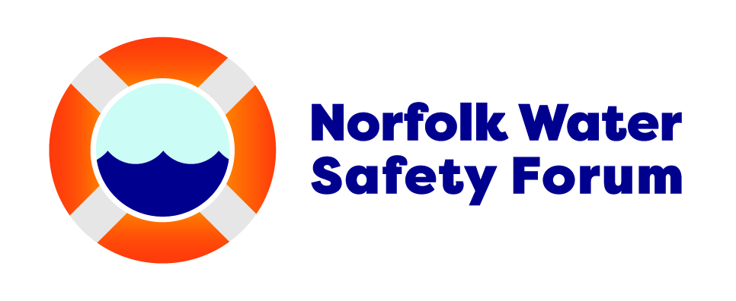
Drowning Prevention Week 2026 – resources for clubs and youth groups
Introduction
Drowning Prevention Week is a campaign from the Royal Lifesaving Society, aimed at teaching water safety to children and young people and prevent accidental drowning.
It takes place from Saturday 13th to Saturday 20th June.
How you can help
• Deliver a short session on water safety using the resources on our website
• Post about water safety week on your social media channels – using some of the suggested messaging below
•Send a WhatsApp message about Drowning Prevention Week (This week is Drowning Prevention Week. We want to share a few water safety tips to help keep everyone safe. If you get into trouble in the water – Float to Live. Lie on your back, with your ears submerged and put your arms and legs out in a star shape. If you see someone in difficulty in the water, call 999 – do not go in after them. Life jackets save lives – always wear one on boats and when doing water sports)
• Share copies of the Water Safety Code and other resources online or in the attachments to this email
Key water safety messages
- Plan ahead and avoid swimming alone
- If you see someone in trouble in the water, call 999 immediately – if you are at the coast or the Broads, ask for the Coastguard, if you are at any other inland water, ask for the fire service
- Float to Live
- Avoid alcohol near water
- Wear lifejackets where appropriate
- Take care near the water – almost half of the people who drown did not mean to enter the water
- #BeAMate – speak up if your friends are taking risks in and around the water. It could save their life.

Call to action
Know the risks. Make safe choices. Float to Live.
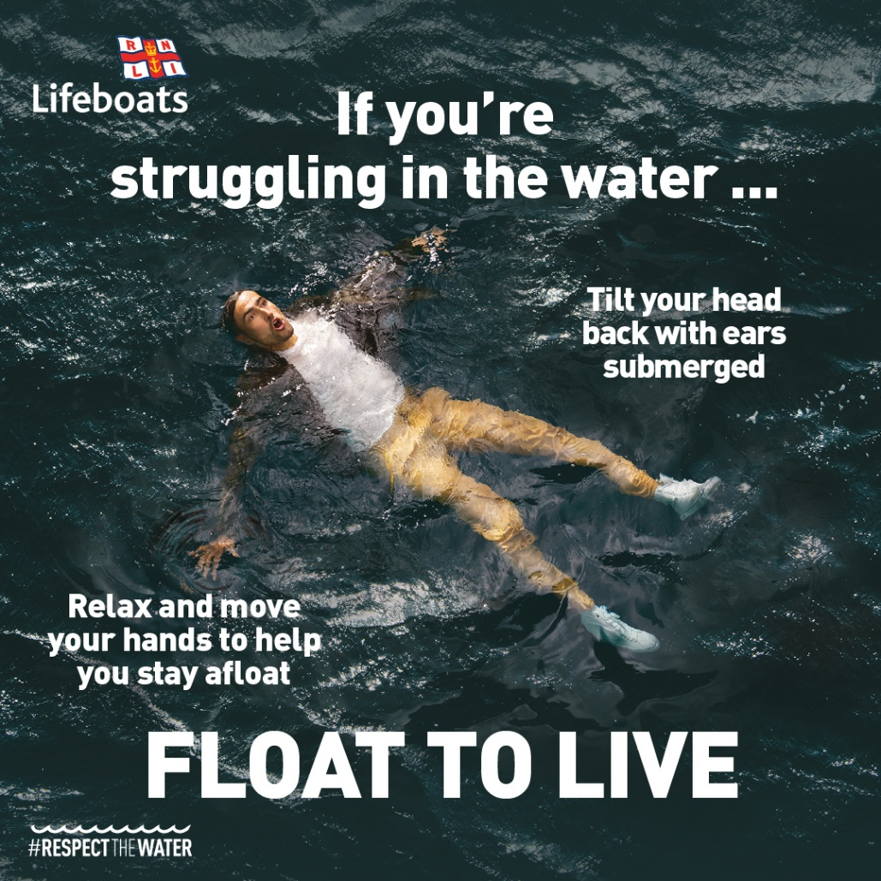
Suggested social posts
Post 1: Heading to the beach/Broads/water? Always plan ahead and stay safe. #DrowningPreventionWeek #DPW2026 #BeAMate
Post 2: In trouble in the water? Float to Live. Tilt your head back and relax. Spread your arms and legs out and bring your breathing back under control. Then you can signal for help. #DrowningPreventionWeek #DPW2026 #BeAMate
Post 3: See someone in difficulty in the water? Call 999 – do not go in after them. #DrowningPreventionWeek #DPW2026 #BeAMate
Post 4: Be a mate this summer – speak up if your friends are taking risks in and around the water. It could save their life. #DrowningPreventionWeek #DPW2026 #BeAMate
Post 5: Life jackets save lives. Always wear one when you are out on a boat or doing water sports. Make sure you put it on before you get to the water’s edge. #DrowningPreventionWeek #DPW2026 #BeAMate

Useful links
Drowning Prevention Week resources for schools, swim schools, clubs etc. Download the Drowning Prevention Week 2026 Resources | Royal Life Saving Society UK ( RLSS UK )
Water safety messaging and resources from the RNLI
Water Safety Advice And Tips - Know The Risks
RNLI Education Resources For Young People
Water safety advice from HM Coastguard
Safety advice | HM Coastguard UK
Norfolk Water Safety Forum Resource Pack 2026
Water safety resources - Norfolk County Council
Boating safety from the Broads Authority
Safety
Water safety from Norfolk Fire & Rescue Service
Safety on or near water - Norfolk County Council

